*Logistic Regression*

Logistic regression is a type of regression that predicts the probability of a **binary outcome**, such as yes or no, spam or not spam, or crack or no crack.

It is based on the **logit function**, which transforms the odds of an event into a value between 0 and 1, representing the probability of the event.

Logistic regression is widely used in various fields, such as biology, social sciences, and machine learning, to model the relationship between a **categorical dependent variable** and a set of independent variables.

Logistic regression can handle both continuous and discrete independent variables, and can also incorporate interaction and nonlinear effects.

Logistic regression can be used for **classification problems**, such as email spam detection, credit card fraud detection, or disease diagnosis, by setting a threshold for the predicted probability.

Logistic regression can also provide measures of uncertainty, such as confidence intervals and p-values, for the estimated coefficients and predictions.

*Perceptron Trick*

[What is a Perceptron? – Basics of Neural Networks | by Anjali Bhardwaj | Towards Data Science](https://towardsdatascience.com/what-is-a-perceptron-basics-of-neural-networks-c4cfea20c590)

*https://towardsdatascience.com/what-is-a-perceptron-basics-of-neural-networks-c4cfea20c590*

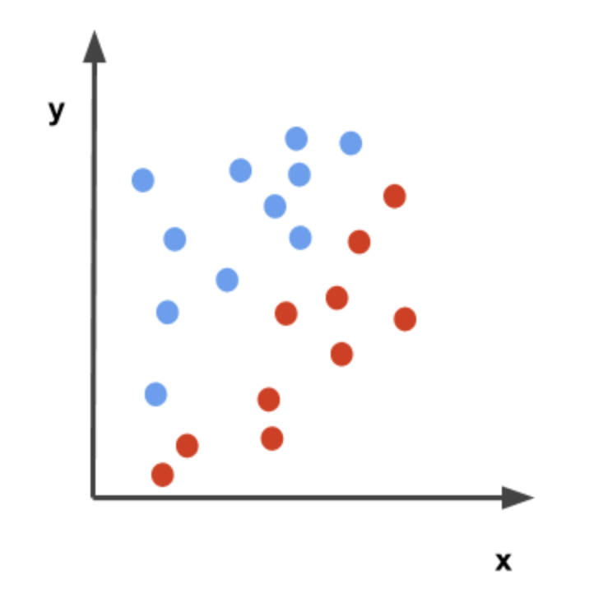

**Overview of all Steps how it works :**

1. Ek random line kesath starte krenge pehle
2. Line ke 1 taraf placement hojayega & dusre taraf Placement nahi hoga
3. In Perceptron we Run A Loop (epoch)
4. Loop ke andar hum random point select karte hai (random student) Hum point se puchenge ki yeah
5. line sahi jageh hai ki galat jageh hai.
6. If sahi jageh hai then kuch nahi karenge but
7. Then loop chalega vapas 1 random point pakdenge &
8. If galat jageh hoga point then Hum Line ko Push Karenge vo particular point ke hisabse.
9. Ese Loop(epoch) mai krte krte Sbh Settle karlenge !

*Transformation Kaise horha in Perceptron Trick. Let’s Try too understand this.*

*Bade Transformation kbhibhi apply nahi krte*

*Instead hum chota number lete basically Learning Rate 0.1 .*

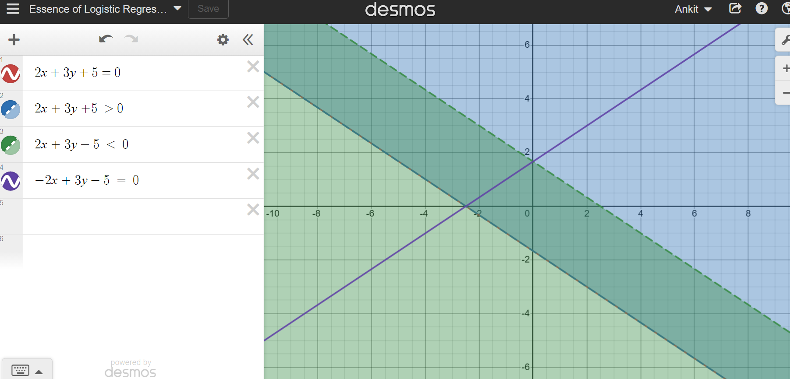

**Ax + By + C = 0**

C mai changes karnese Parallel changes hote hai

A mai changes karnepe jo Y-axis hai uspe rotation karte hai

B mai transformation karnese x ke yaha krte hai

*Sbhka one by one smjhte hai chalo*

**Ax + By + C = 0**

*The graph shows detail about when we do changes in C what happens*

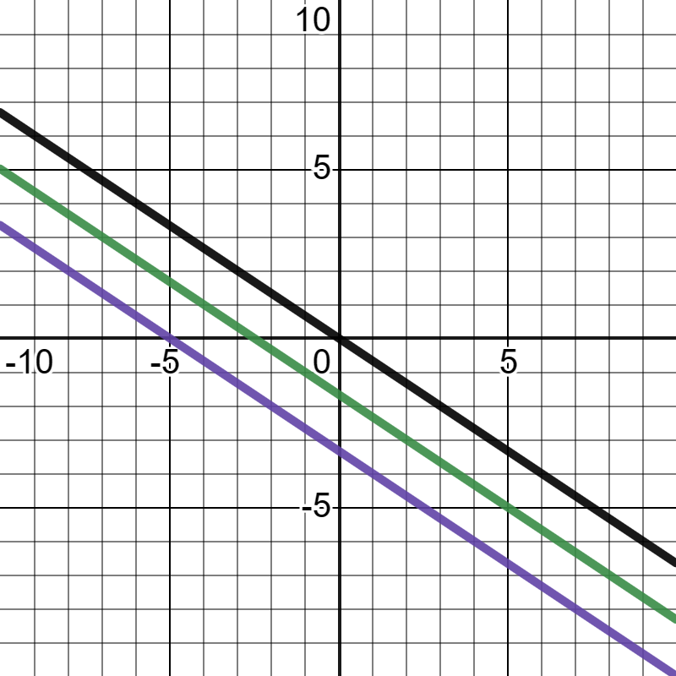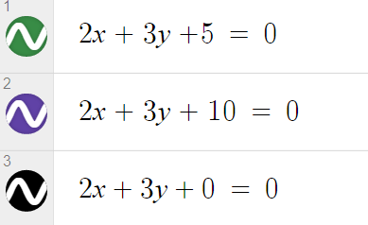

*When we change the weights of A*

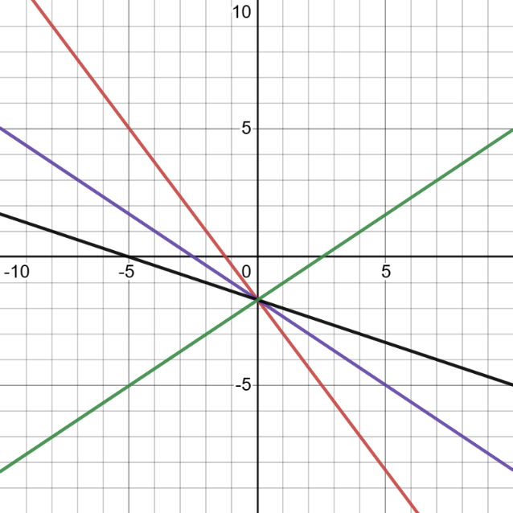**Ax + By + C = 0**

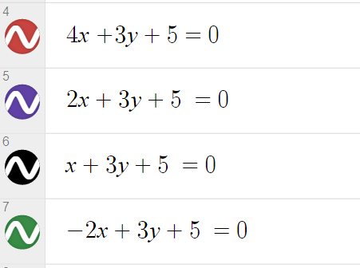

**When we change the weights of Y**

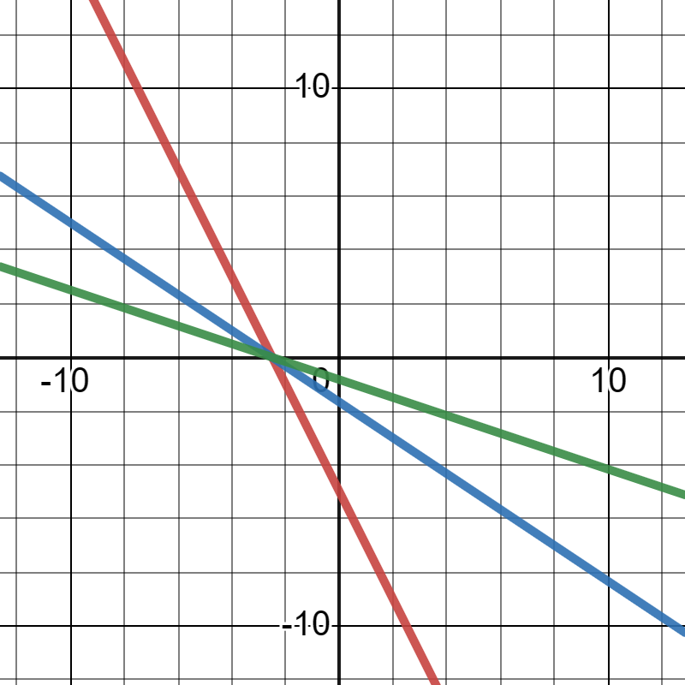

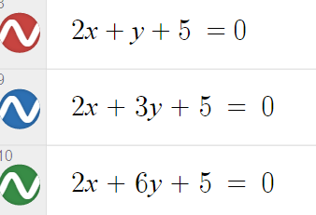

*Summary (Ekbaar vapas smjhunga Required Maths krke properly )*

*Agar Negative point +ve region mai hai then hum*

*Uske coordinates mai last mai 1 lagake Line ke coefficient se*

*Subtract karenge*

*Agar +ve point*

*Coordinates ko pakadke Learning rate se multiply krte hai*

*Perceptron Trick last stage pe rukkjaaraha hai & aageh improve nahi krrha*

*Perceptron ka Problem yeahi hai ki Humme Best Line Nahi millta hai ishe , coz algorithm vaisa hai ki jaise misclassified point 0 huye vaise vahi point pe rukkgaya & vahi Line dediya aageh improve nahi hua*

*Where as Logistic Regression aageh Bhi Improve karta hai that’s why we don’t use Perceptron Trick in Logistic Regression.*

*Now Let’s understand Logistic Rgression ka Actual Approach*